Lab 6 Prep

1. PCB Artist

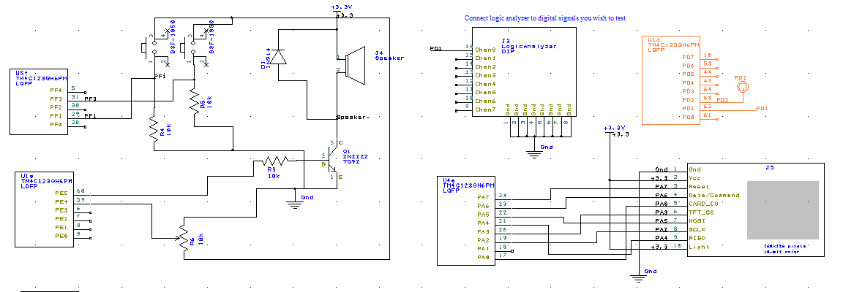

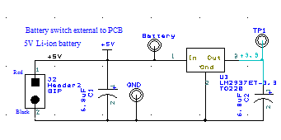

1. Battery

Dimensions: 9.2 x 2.5 x 2.5cm (LxWxH)

Energy Storage Capacity: 2200mAh

Cost: N/A (already had it)

1. Box type: Lab3Box.pcb, Serpac 032C

Link: http://www.digikey.com/product-detail/en/032C%2CBK/SR032-CB-ND/2286005?curr=usd&WT.z_cid=ref_octopart_dkc_buynow&site=us

Dimensions: 4.38 x 3.25 x 1.40in (LxWxH)

Price: $7.71

PCB Size: 4 x 3in

1. Ordered a TP731 Speaker Amplifier from TI.
2. 